PROJECT

CREATED BY ALIYAN QURESHI
Aliyanqureshi.002@gmail.com
CONTENTS

- Certification of submission

- Introduction

- Objectives of the project

- Problem statement

- Deliverables

- Hardware/Software requirements

- ER Diagram

- UI Interface

INTRODUCTION

The thirst for learning, upgrading technical skills and applying the concepts in real life environment at a fast pace is what the industry demands from IT professionals today. However busy work schedules, far-flung locations, unavailability of convenient time-slots pose as major barriers when it comes to applying the concepts into realism. And hence the need to look out for alternative means of implementation in the form of laddered approach.

The above truly pose as constraints especially for our students too! With their busy schedules, it is indeed difficult for our students to keep up with the genuine and constant need for integrated application which can be seen live especially so in the field of IT education where technology can change on the spur of a moment. Well, technology does come to our rescue at such times!!

Keeping the above in mind and in tune with our constant endeavour to use Technology in our training model, we at Aptech have thought of revolutionizing the way our students learn and implement the concepts using tools themselves by providing a live and synchronous eProject learning environment!

So what is this eProject?

eProject is a step-by-step learning environment that closely simulates the classroom and Lab based learning environment into actual implementation. It is a project implementation at your fingertips!! An electronic, live juncture on the machine that allows you to

o Practice step by step i.e. laddered approach.

o Build a larger more robust application.

o Usage of certain utilities in applications designed by user.

o Single program to unified code leading to a complete application.

o Learn implementation of concepts in a phased manner.

o Enhance skills and add value.

o Work on real life projects.

o Give a real life scenario and help to create applications more complicated and useful.

o Mentoring through email support.

The students at the centre are expected to complete this eProject and send complete project along with the documentation to eProjects Team

Looking forward to a positive response from your end!!

OBJECTIVES OF THE PROJECT

The Objective of this program is to give a sample project to work on real life projects. These applications help you build a larger more robust application.

The objective is not to teach you JavaScript/Dreamweaver but to provide you with a real life scenario and help you create basic applications using the tools.

You can revise the chapters before you start with the project.

This project is meant for students who have completed the module of Dreamweaver. These programs should be done in the Lab sessions with assistance of the faculty if required.

It is very essential that a student has a clear understanding of the subject. Students should go through the project and solve the assignments as per requirements given.

Kindly get back to eProjects Team in case of any doubts regarding the application or its objectives.

PROBLEM STATEMENT

SIMPLON’s Beauty care centre is very big shop of cosmetics and accessories in the city. With the success of the shop, owner had opened few more shops in the different cities also. Simplon product is known for their quality of the service which they are providing since 1985. In order to advertize about the company and also to start online services the company wishes to make the website of the company. For which they have approach you to design the website and requirement specification for the same is given below:

REQUIREMENT SPECIFICATION:
The Web site is to be created based on the following requirements.

1) The Home Page should be created making with proper sections and with a suitable logo.
2) The look and feel of the project must be made user friendly and uniformity in the color combination must be maintained.
3) About us, Contact Us (address and map) must be added. In the Contact Us page the website of all the shops location must be given.
4) All the categories of the products like HAIR, SKIN, MAKE-UP KITS, NAIL PAINTS, NAIL ARTS, JEWELLRY, WEDDING KITS, UPCOMING PRODUCTS &amp; so on. For each product the cost must be mentioned in the list. 5) Feedback page must be added to take the valuable feedback from the users.
6) Contact Us, About Us.
7) Gallery section can be included.
8) Navigation of the project must be made user friendly.
9) Customer must be allowed to place the order by selecting the product.
10) While placing the dummy order, the total cost of the order must be calculated.

HARDWARE/ SOFTWARE REQUIREMENTS

HARDWARE
• A minimum computer system that will help you access all the tools in the courses is a Pentium 166 or better
• 64 Megabytes of RAM or better

SOFTWARE [EITHER OR COMBINATION AS PER COURSE/SEM]

• Notepad/HTML editor/CoffeeCup
• Angular / Angular JS / React / BootStrap
• Dreamweaver / Figma
• MS IE / Chrome / FireFox / Netscape /MS Edge

PAGES NAMES

- HOME

- SHOP

- SHOP DETAILS

- CONTACT

- PAGES
SHOPPING CART

HOME:



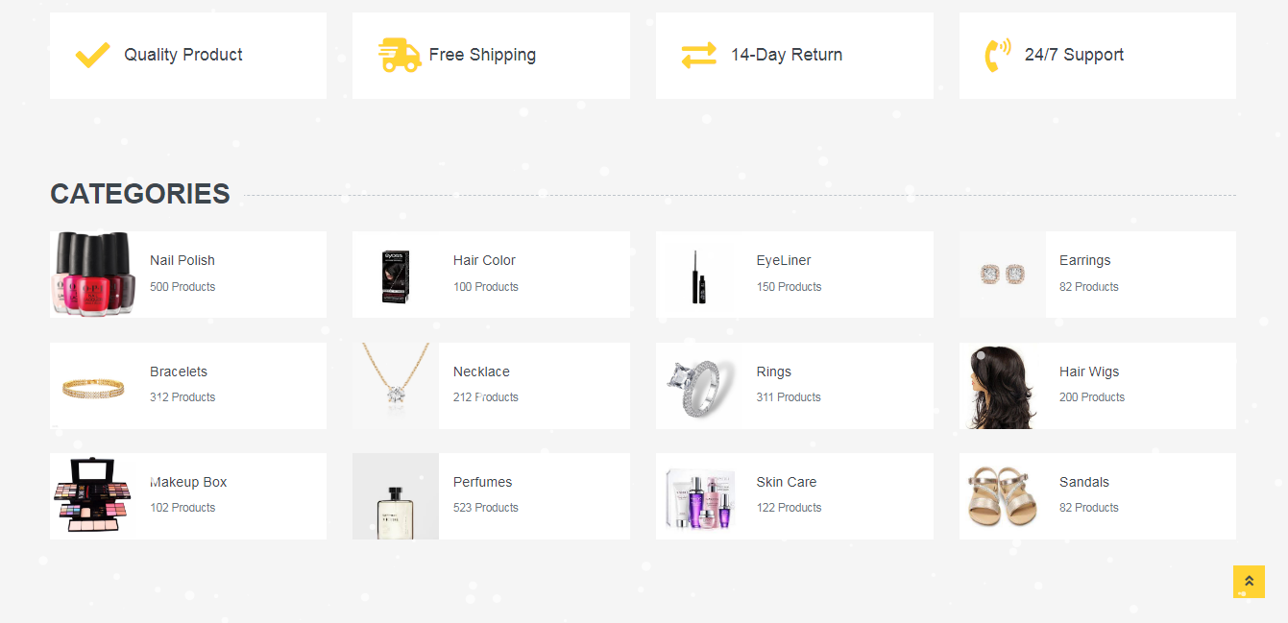





SHOP:

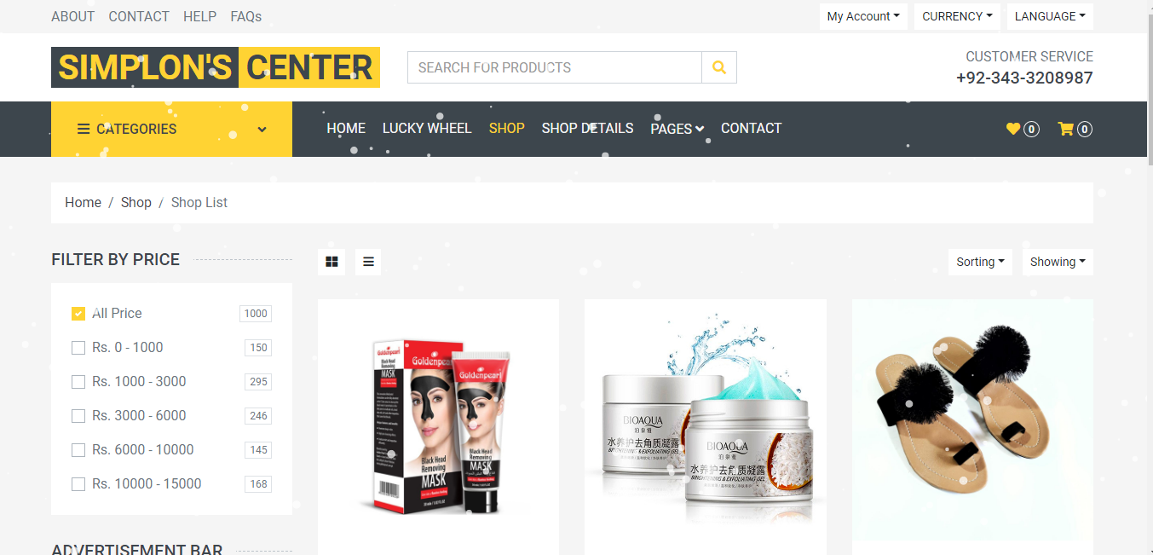


SHOP DETAILS:

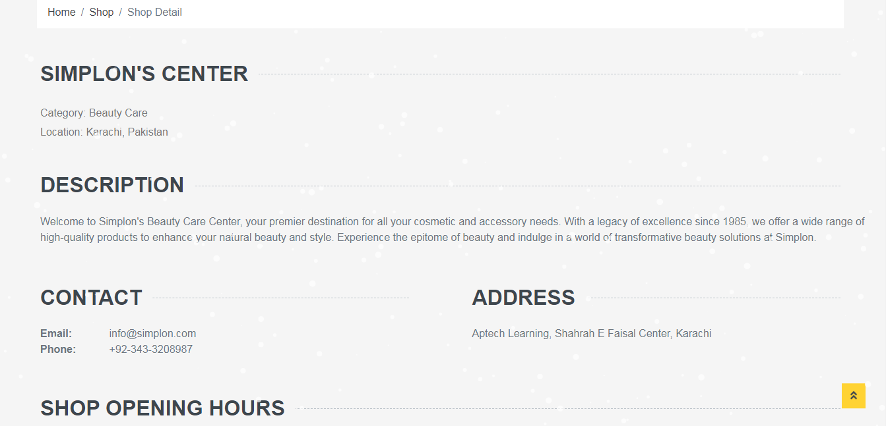
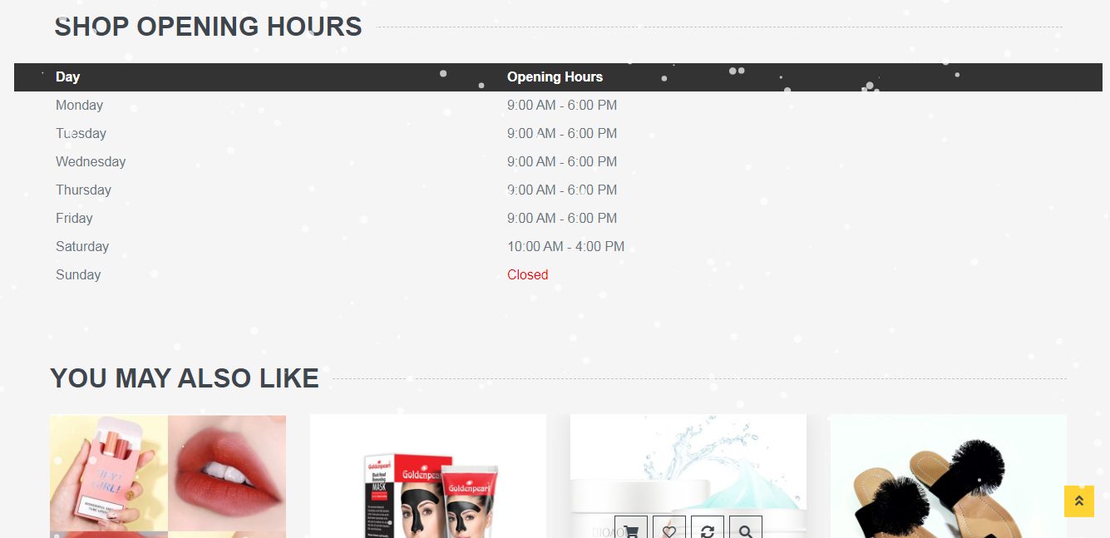

PAGES – SHOPPING CART

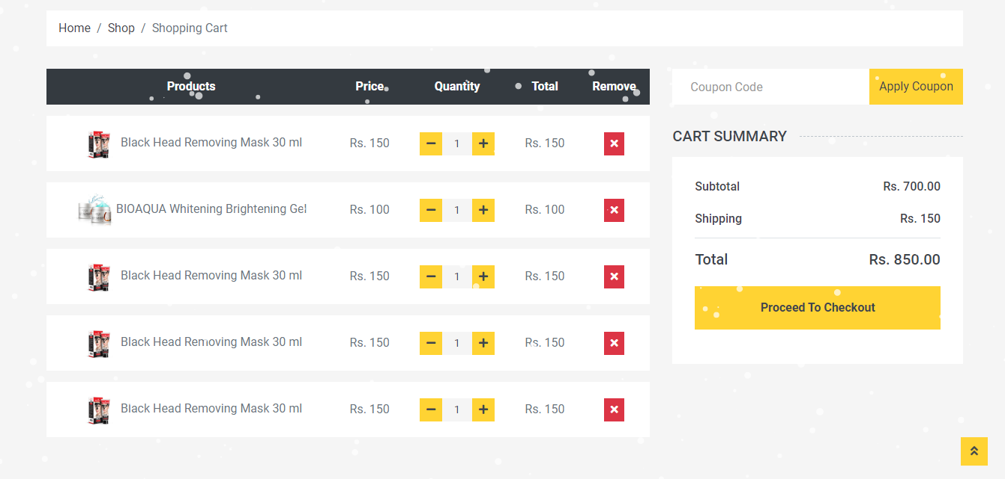

CONTACT:
